**REPORTS**

**Reports communicate information which has been compiled as a result of research and**

**analysis of data and of issues**

**ACCOUNT LEDGER**

**Account**  ledger contains a record of business transactions.

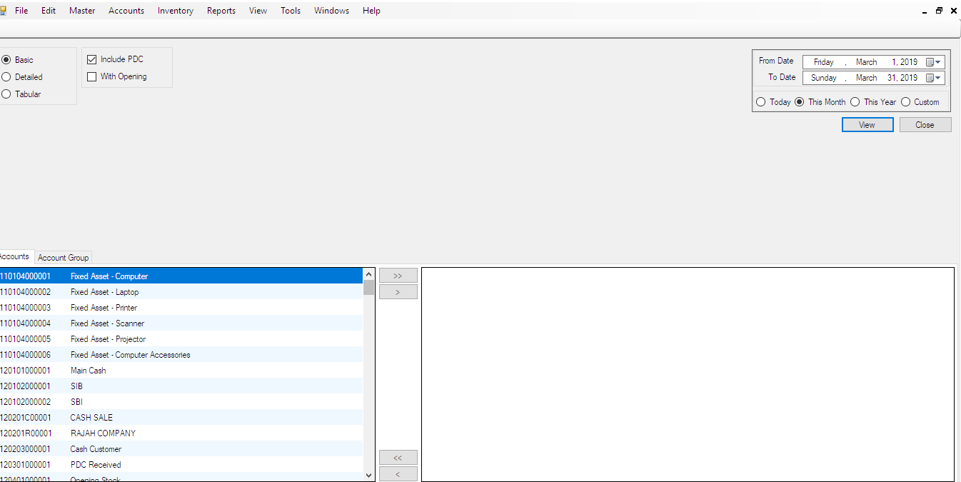

**Detailed**

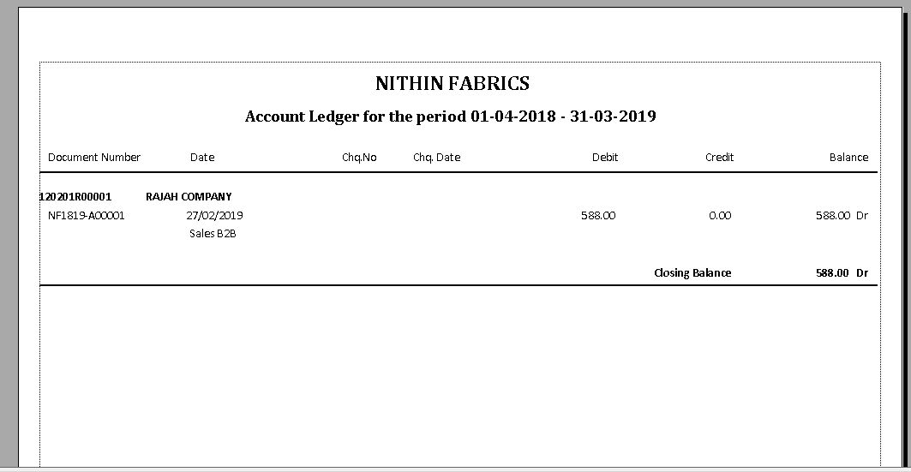

**Tabular**

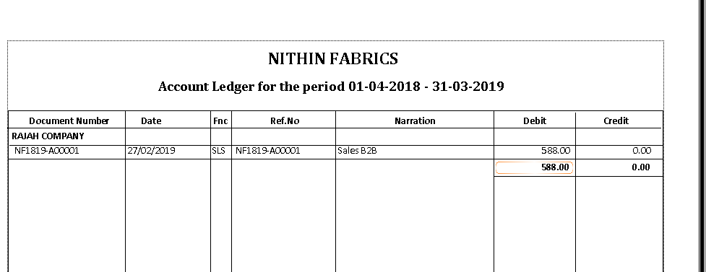

**With opening**

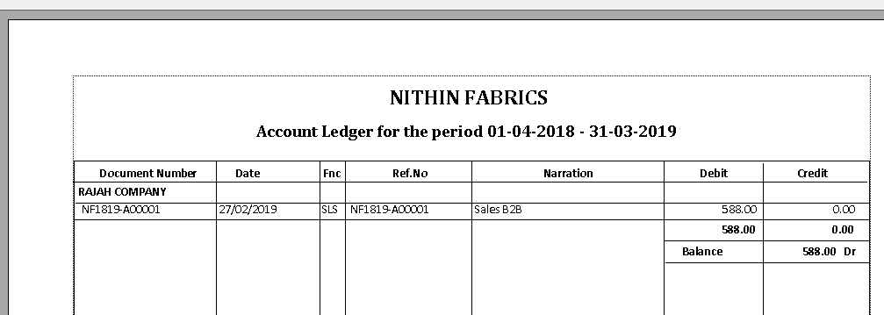

**ACCOUNT BOOKS**

which all the transactions that take place in a bank account or a company's.

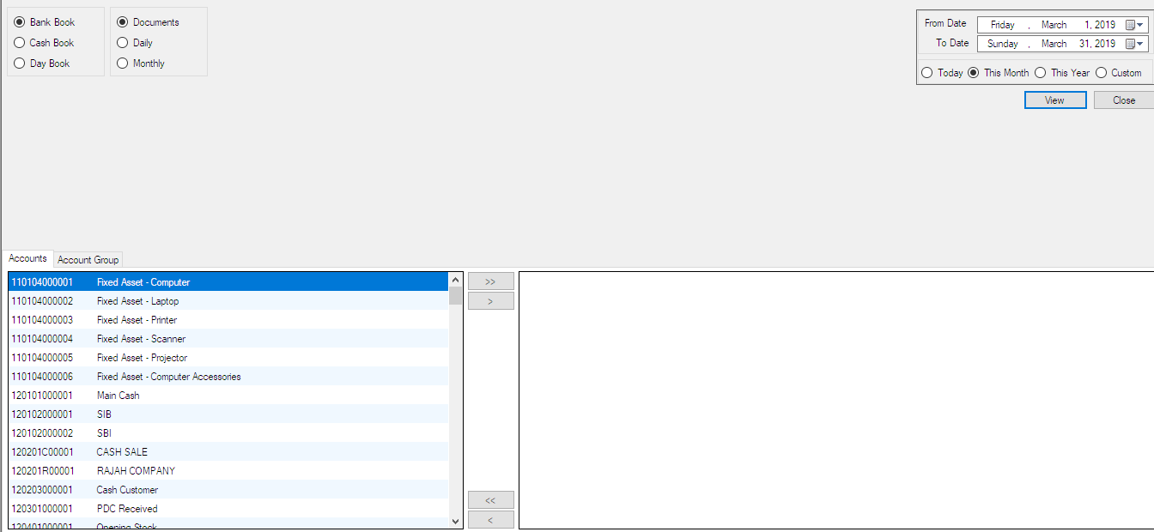

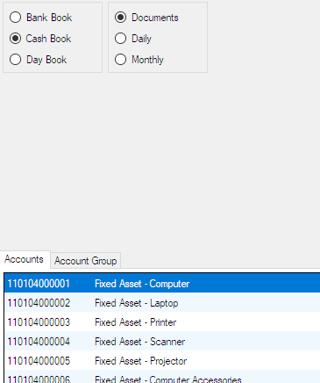

**Cash book**

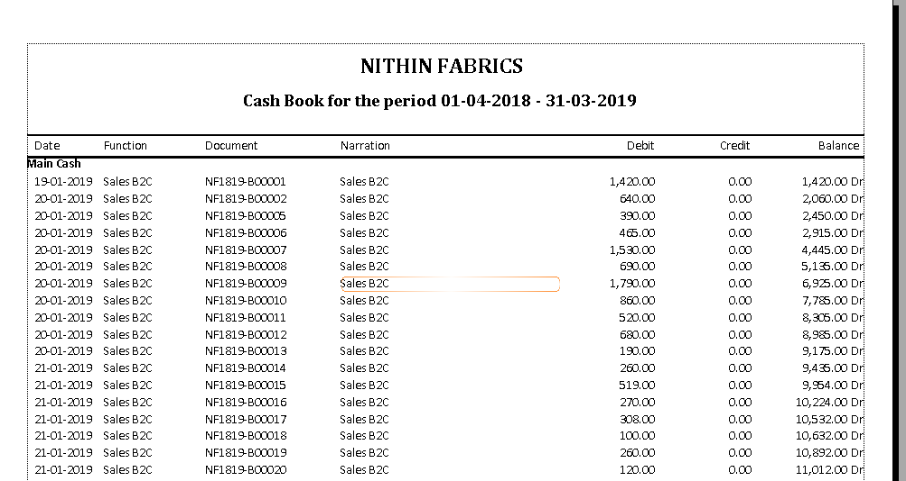

**Day Book**

